**Optimizing Course Scheduling at Marshall**

**Interim Deliverable 1 - Classroom Utilization**

By

Babak Biglari

Jennah Crotts

Linda Jianyi Liu

Laura Qin

Jesse Weiss

DSO 570

March 6th , 2018

**Goodness for Various Stakeholders**

The ultimate goal of our project is to create an efficient system to allocate the university’s resources in order to meet stakeholders’ demands. The datasets provided include Marshall Course Enrollment, Room Capacity, Course selection, Department Allocation and information regarding Special Sessions. Our initial discussion regarding this project’s main area of improvement involved identifying the primary parties of interest. There are multiple stakeholders in this project; including students, faculty, departments, program and administration. They do not always have the same goals.

|  |  |  |  |  |  |
| --- | --- | --- | --- | --- | --- |
|  | Students | Faculties | Departments | Programs | Administration |
| Issue | Variety of courses, Conflicts | Back to Back Classes | No overlap between popular courses | Cores and electives don’t conflict | Cost efficient use of space |
| Metric | Number of multiple time slots for popular courses. | Boolean Variable (1 yes, 0 No) | Boolean Variable  (1 yes, 0 No) | % of all cores class time that overlaps with electives | % of “Prime Time” used by room |

**Inefficiency Found for Current Class Scheduling System**

The current system is primarily focused on finishing the scheduling on time and it has an embedded systematic bias because most schedules are done by the department coordinators. These assignments are typically done based upon availability and faculty demands with little consideration for balancing the goals of the above stakeholders. Through our discussion, we decided that optimizing the usage of classroom space could potentially address multiple stakeholders’ requirements. The inefficient usage of classroom space creates bottleneck whose effects spread through the scheduling system.

**Identifying Major Opportunity for Improvement**

We believe that the major opportunity for improvement comes from the efficient usage of the classroom space. In our process of optimizing classroom space usage, we made a few assumptions regarding the demand for classes at certain time slots: (1) We decided to choose the boundaries for high-demand times arbitrarily by analyzing the entire day and choosing the times that were the most densely populated by registered students in the historical data we were given. (2) We assumed that the observed trends remain consistent in future terms. This inference is a result of usage of historical data for our analysis. (3) We assumed that listed classrooms capacity is consistent semester to semester and does not lose functionality from equipment breakdown or other wear and tear.

**Defining Notion of Goodness**

Considering the importance of class space usage, we believe efficiency in classroom usage- specifically in individual seats rather than entire rooms- is the best notion of “goodness”. The higher the utilization of space during high-demand times, the better the system. At this stage of our project, we are trying to establish minimum viable product (MVP) to show that optimizing classroom utilization during peak time should be the first point of focus as freeing up more time throughout the day allows more classes to be scheduled in preferred prime time. Following our aforementioned assumptions, we set 8AM to 8PM as our boundaries for high demand time slots.

**Measure of Goodness - Metrics and Related Benchmarks**

Moreover, we identified two related metrics as our key measures for goodness. The first was simply the difference between the seats registered and the classroom capacity. This led us to a more appropriately robust metric, which is the percentage of classroom seats that are occupied across all classrooms during peak times. This second metric was what we chose to analyze in this deliverable, shown in the coding below.

There are multiple constraints regarding the scheduling system: increasing demand for Marshall classes, scheduled building renovations, and conflicting priorities etc.. The undergraduate population at Marshall is the largest of any undergraduate program at USC. In addition, the graduate program has no less than 9 distinct programs running with their own requirements, priorities, and complex processes. The already strained classroom space is exacerbated by a scheduled renovation which makes efficient classroom utilization even more important. Moreover, the classrooms themselves have a limited number of seats. Therefore, this is very important to link the right class to the course with certain occupancy which maximizes the utilization of class space. Furthermore, each seat represents a student during a portion of their programmatic hours. Therefore, this granular level of fitness analysis appropriately places the focus on the student and their experience. This also has the added benefit of balancing a different stakeholder’s priorities against those of the department and faculty who are immediately involved in the scheduling.

**Computing the Metrics with Python**

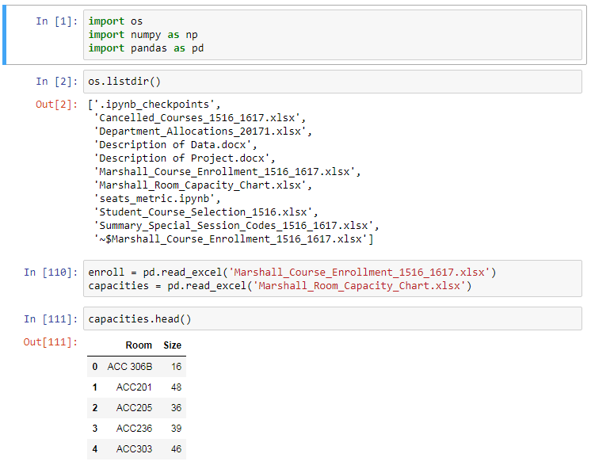

We organized the capacity of rooms in a table

Populate primeDict with the actual number of students enrolled associated with each term, room, day and time

- primeDict: use term, classroom, and day-of-week as key, each key is associated with the number of students enrolled.

- termSet, roomSet and dayList: sets of possible terms, classrooms and days

- primeTime: 8AM to 10PM, converted to a list of minutes with 5-minute intervals

Method that converts time into minutes

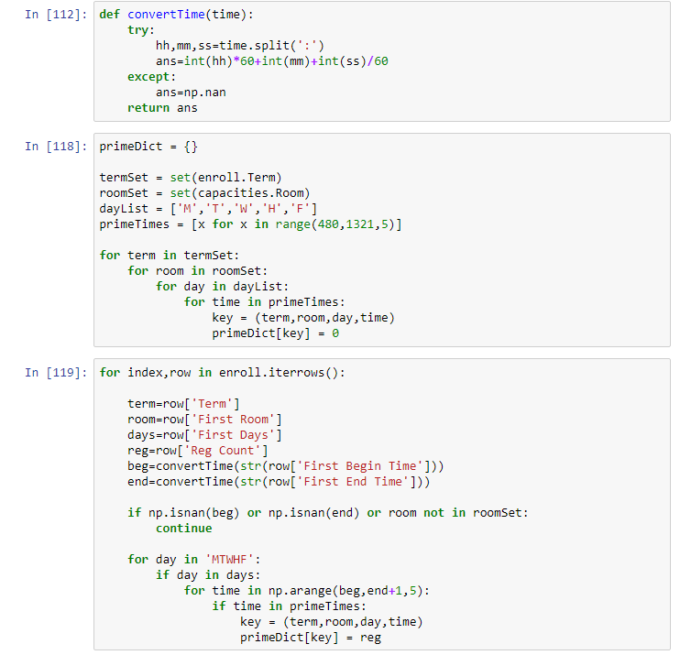

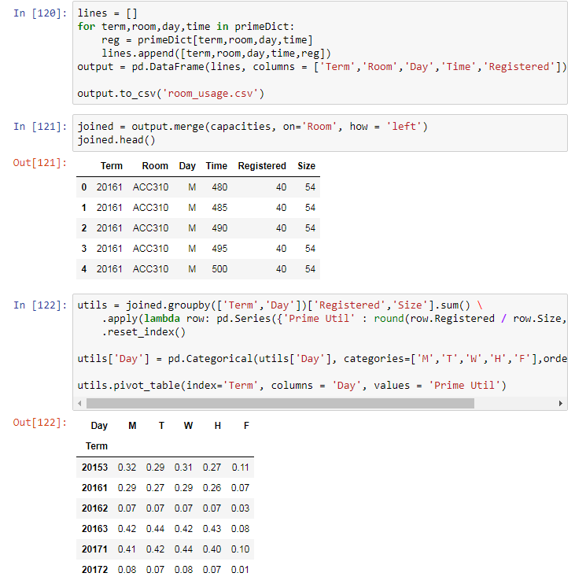

Combine the contents of primeDict with classroom capacity, joined by classroom

Using the joined table, calculate the average % of seats occupied during peak time, grouped by day of week and term

Using the room usage data we calculated, we made a visualization of percentage of classroom seats occupied in any given time between 8AM and 8PM, grouped by day of week and terms. From the visualization we can see that the overall utilization rate increases over the last two years, probably due to increasing demand of Marshall courses. Interestingly, in both spring 2016 and spring 2017, classrooms are under-utilized on Tuesday and Thursday from 2PM to 4PM, which could be an indicator of room for improvement.

